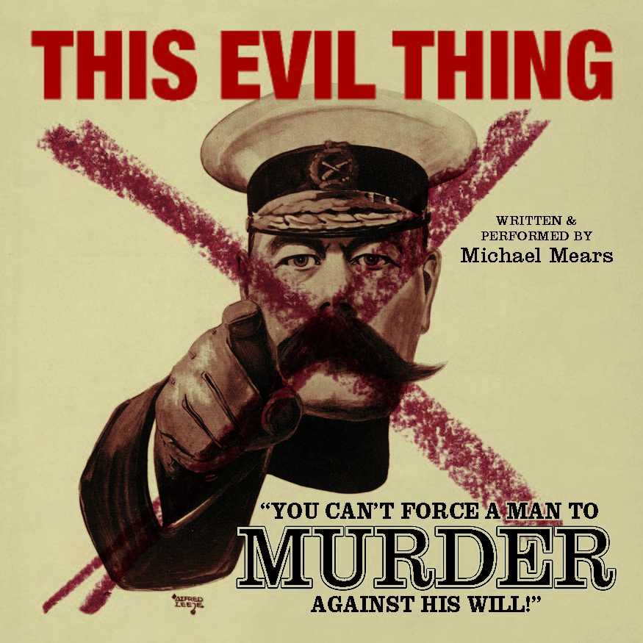
THIS EVIL THING
written and performed by Michael Mears

New Town Theatre, Venue 7
96 George Street, Edinburgh, EH2 3DH

August 4th-28th2016 (not Aug 16 or 23)
12noon (duration 75mins)

Tickets: £13-£9
Tickets can be bought at the door
www.TheNewWeeTheatre.co.uk
On the Fringe App.
On 0131 226 0000
www.facebook.com/thisevilthing

'For God's sake! This protest of yours – is it really worth losing your lives over?'

January 1916: Bert Brocklesby is a young schoolteacher, and preacher at his local Methodist church;Bertrand Russell is one of the greatest mathematicians of his time. With the advent of military conscription their worlds are about to be turned upside down.

THIS EVIL THING is the compelling, shocking and inspiring story of the men who said no to war; a rarely told story involving a dizzying journey from a chapel in Yorkshire to the House of Commons; from an English country garden to a quarry in Aberdeen; from a cell in Richmond Castle to a firing squad in France.

‘18? You’re too young to have a conscience!’

With military conscription still in force in many countries today, and prisoners of conscience still languishing in jails, the questions posed by THIS EVIL THING are as relevant and urgent as they were one hundred years ago.

‘Michael Mears is that rare combination of fine writer and formidable actor.’
– BONNIE GREER, Time Out

